**REPORT**

Hanoi

This program was implemented to demonstrate a recursive solution to the Towers of Hanoi problem. The program itself is very simplistic, and simply prints out the order and positions to move the disks of the towers to and from to successfully solve the tower given the number of disks.

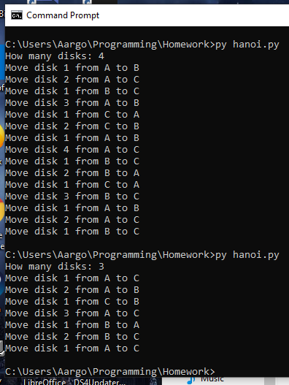

Tree Ordering

This program was implemented to demonstrate the in-order and pre-order traversals of a tree. The user inputs the tree as a series of numbers, separated by spaces, or the value “null”, which is converted in Python to the None value. A tree datastructure is constructed from this array, and is capable of printing itself in both an in-order and pre-order traversal.

